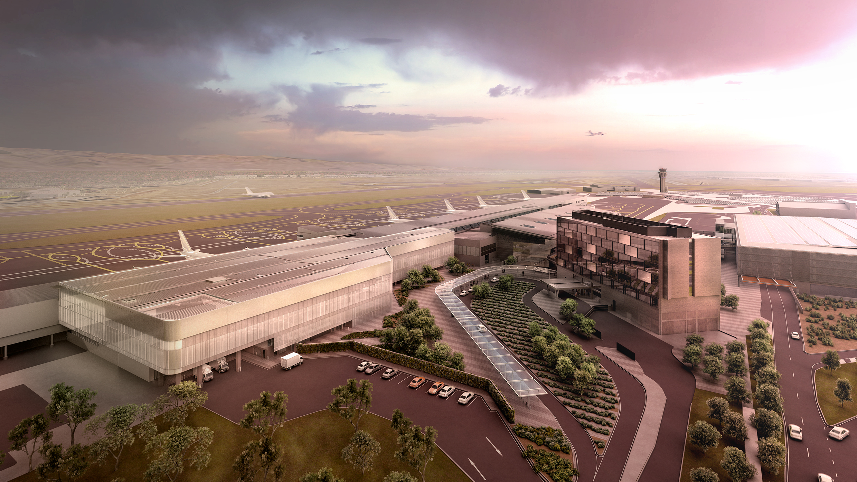

**TEx construction continues despite COVID-19**

**Partial terminal closure assists construction program**

**Current customer impact**

* Northern and part of the central terminal areas are currently closed for public access.
* Noise generated by construction activity may be heard in close proximity to work zones inside and outside the terminal.
* There have been recent changes to customer experience and retail offerings.
* Construction activity has resulted in a reduction in the width of the concourse and changes to gate lounge access in some areas. The use of people mover buggies by airlines is currently suspended.
* Check in and boarding times for essential travellers are as recommended by your airline.
* Due to COVID-19 restrictions, only passengers with a current boarding pass are permitted to proceed past the main screening point. Exemptions include carers providing care to a passenger, parents of unaccompanied minors, airport staff and contractors working that day, and law enforcement and SA Health officials.

**Latest update**

* The first section of the new retail concourse was opened to the public on 26 February.
* Significant changes have occurred to the overall terminal environment as a result of the impact of COVID-19.
* Demolition of Aviation House is complete and piling and footing works for the building pad have commenced.
* Construction and refurbishment works continue throughout the terminal. For the most up-to-date information, go to <https://www.adelaideairport.com.au/corporate/about-us/projects/terminal-expansion-project/>.
* The northern end of the terminal is currently closed to public and staff. All operations have been moved to the southern end of the terminal.
* Retailers have been significantly affected due to COVID-19, however Muffin Break has recently re-opened to essential travelers and staff between 5am and 5pm. Subway also remains open in the plaza, while the Atura Hotel is open for breakfast and lunch. More details can be found at [Retail News](https://www.adelaideairport.com.au/corporate/about-us/projects/terminal-expansion-project/retail-news/).

**Construction Facts**

* More than 120 workers currently on site with more than 470,000 man hours on the project up to the end of April 2020
* 2,000 tonnes of steel installed
* 4,700 cubic metres of concrete poured
* 2600 square metres of precast concrete installed

**Project Milestones**

* Demolition of Aviation House in preparation for Phase 3 works
* Significant advances in project works across all levels.

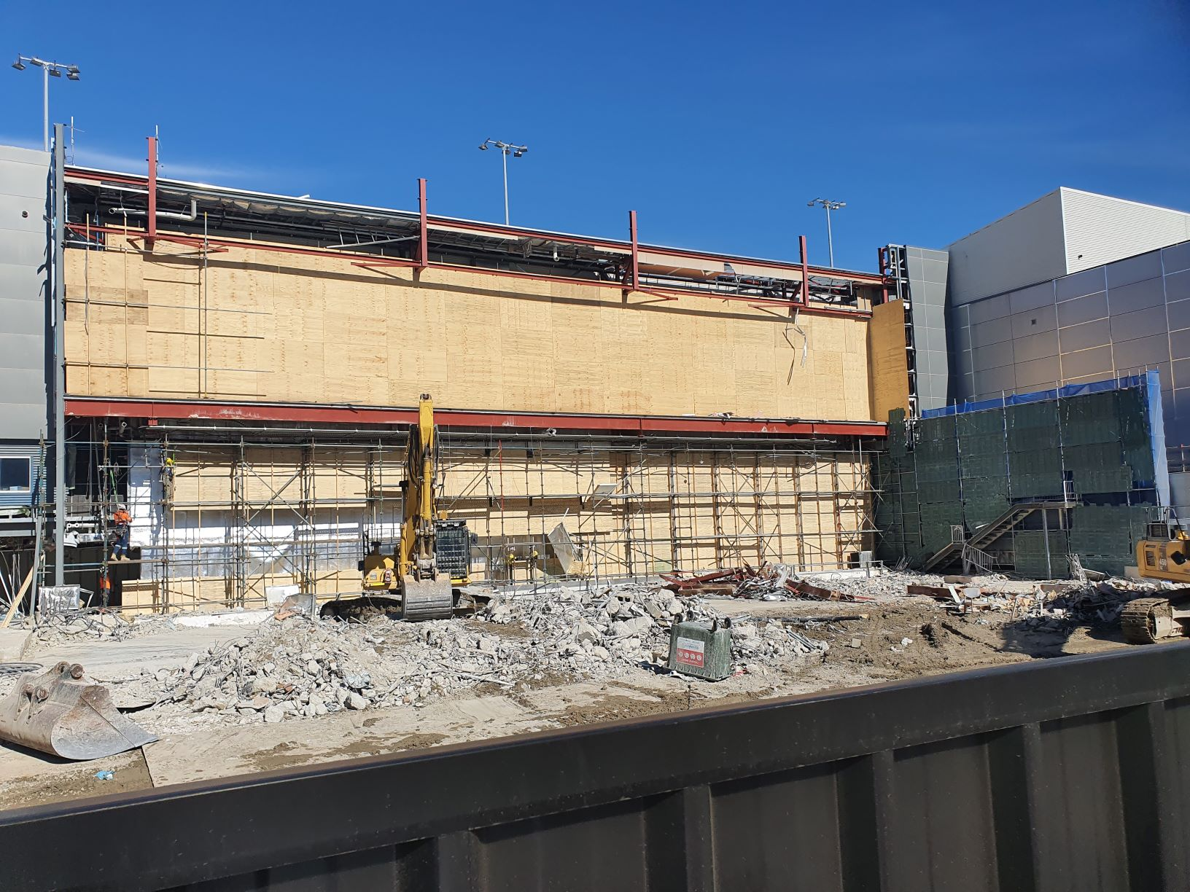

*Demolition of Aviation House*

If you wish to provide any feedback or make an enquiry relating to the Terminal Expansion, please contact Amy Mitchell, Stakeholder Manager – Terminal Expansion Project on 8308 9384 or [amitchell@aal.com.au](mailto:amitchell@aal.com.au)

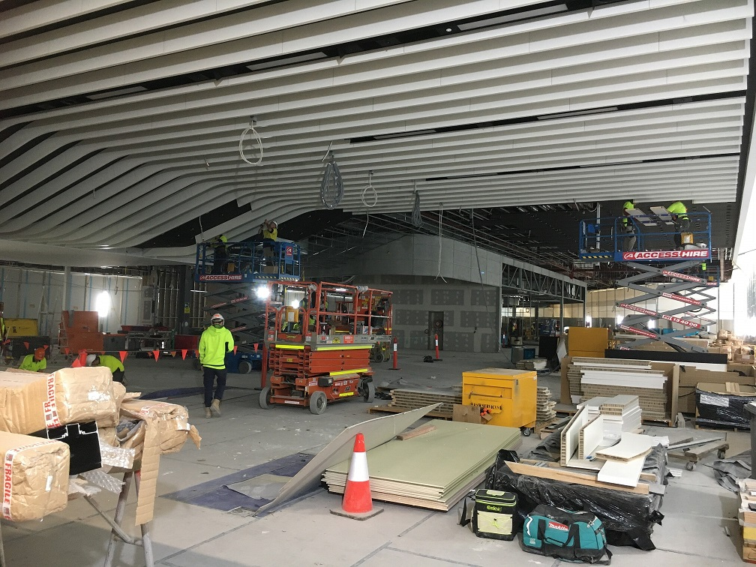

*Central concourse refurbishment well advanced*

**Project Fast Facts**

* Expanded duty free precinct for international arrivals and departures
* More than 80 per cent increase in retail and dining precinct
* Expansion of international arrivals and departures immigration processing and security screening space
* Improved family facilities
* Gate 18 to be dedicated international departures gate
* Second international baggage belt
* New common user lounge for international departures
* Virgin Australia lounge to be relocated and expanded
* Workforce to reach 200 people at peak construction
* Additional 630 direct and indirect jobs due to retail expansion